# Name:Shantanu Janradhan Kantode

# Roll No:57 Sec: A Subject: BDA

# Practical No. : 9

# AIM: To Study and Installation of Weka AI Tool

# What is Weka?

Weka (Waikato Environment for Knowledge Analysis) is a popular open-source tool for data mining and machine learning, developed by the University of Waikato, New Zealand. It provides a GUI for easy access to powerful algorithms for:  
- Data preprocessing  
- Classification  
- Clustering  
- Regression  
- Visualization  
  
Weka supports files in ARFF, CSV, and other common formats.

# Installation Steps

## Step 1: Download Weka

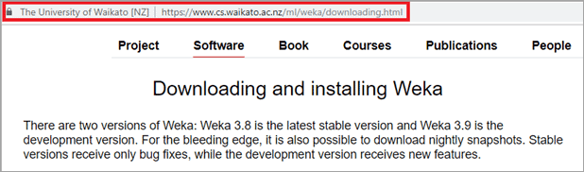

## Step 2:

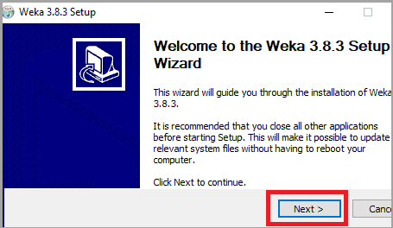

## Step 3: Click on Next.

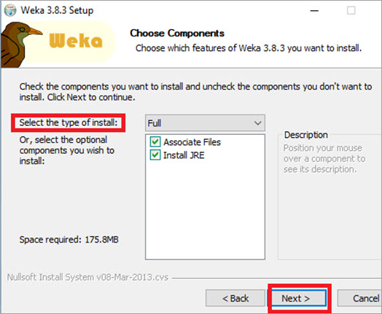

## Installation Window

## Step 4 :  If Java is not installed in the system, it will install Java first.

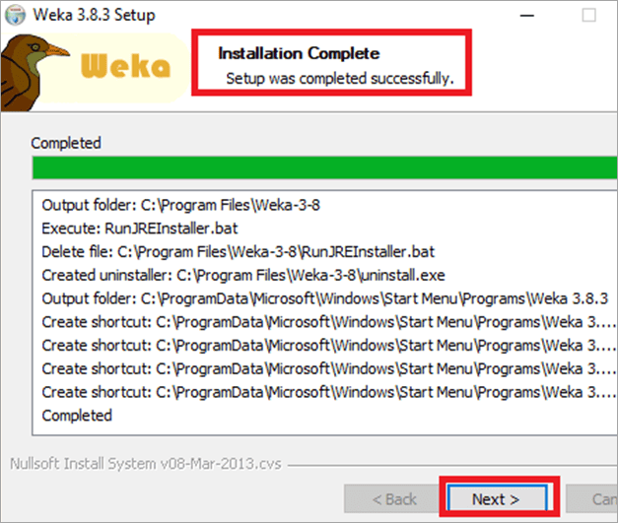

## Step 5 :  Select the Start Weka checkbox. Click on Finish.

## Select the Start Weka checkbox

## Step 6 :   WEKA Tool and Explorer window opens.

## WEKA Tool and Explorer

## Step 7 : WEKA Explorer windows show different tabs and Here , we have install the weka software

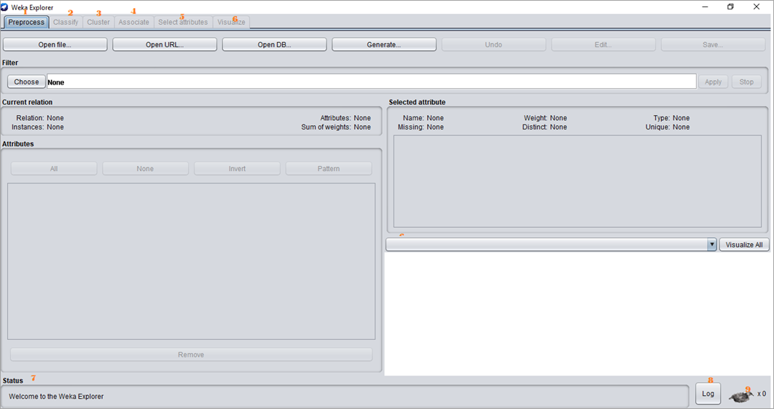

# Conclusion

Hence , We have study and install the Weka AI Tool.